
School of Software Engineering: Intelligent Systems

Shared stories for combating elderly loneliness: Using LLM for recovering common context in free-from reminiscence narrative

Final Project Book

Student name: Eden Moran
Supervisor: Dr. Yehudit Aperstein
Advisor: Dr. Sasha Aperstein
Date:

1. Motivation
Loneliness and cognitive decline are significant issues faced by the elderly, requiring effective support mechanisms. Connecting individuals through shared memories can alleviate isolation and enhance mental health. Shared memories are typically identified via common contexts such as people, places, and events. However, these contexts are often fuzzy, missing, or implicit within free-form, unstructured, and fragmented reminiscences.
To address this, we propose developing a tool for recovering implicit reminiscence context (IRC) from these personal narratives. We assume that the input narratives are fragmented, with individuals potentially adding short narratives daily. These narratives are unstructured, not following any specific template for "when, where, what," and are often fuzzy—omitting important details, not following well-formed sentences, assuming a prior knowledge of the context, and including abrupt subject changes or references to previous subjects. The IRC concept offers a new lens through which to view and process the rich, albeit fragmented, narratives of the elderly.
By leveraging the capabilities of Large Language Models (LLMs), we aim to identify key elements like places, events, and temporal references in reminiscence. This framework can facilitate meaningful connections among elderly individuals who have attended the same school, served in the same military unit, or experienced similar significant events in their lives. Recognizing context in free-text reminiscences presents several challenges due to the informal and often unstructured nature of personal narratives, requiring advanced NLP techniques to accurately parse and interpret the text. Additionally, the diversity of expressions and the richness of individual experiences require a model that is capable of understanding nuanced language use. By employing state-of-the-art LLMs, which have demonstrated proficiency in understanding and generating human-like text, this research addresses these challenges. In this work, we start with offline reminiscence text, transcribed from interviews and dialogs, while the goal is to eventually work with interactive dialog as well.
The significance of this work lies in its potential to enhance social connectivity and support community building, especially among the elderly. By identifying shared experiences and fostering connections based on these commonalities, we can contribute to creating more cohesive and supportive social interactions. Facilitating connections based on shared reminiscences can provide them with a sense of belonging and community, which is crucial for their mental and emotional well-being.

2. Introduction
Reminiscence therapy is a type of psychotherapy designed to reduce feelings of loneliness, anxiety, and depression in older adults. This therapy involves the intentional recall of past memories to enhance well-being. Unlike simple reminiscence, which might happen casually, reminiscence therapy is a structured process aimed at therapeutic outcomes (Wang, 2007; Tadaka & Kanagawa, 2007). By engaging in reminiscence therapy, older adults can share their life stories, revisiting both joyful and challenging memories. This process helps them find meaning in their past experiences, which can improve their current quality of life and sense of personal value. It also aids in reinforcing their self-identity (Subramaniam & Woods, 2012). The therapy can be conducted in both group and individual settings, either structured or unstructured, depending on the needs of the participants. Effective reminiscence therapy requires consideration of the setting, therapeutic goals, underlying theories, participant types, and the qualifications of the facilitators (Wang, 2007). Reminiscence therapy can also be a powerful tool for connecting individuals who share memories of the same place and time. By bringing together older adults with common experiences, such as growing up in the same neighborhood, attending the same school, or living through the same historical events, this therapy can foster a strong sense of community and belonging (Azcurra, 2012). Through the shared process of looking back, participants can find comfort and joy in their common heritage, reinforcing their connections and providing a supportive network that helps combat loneliness (Haslam et al., 2010). Overall, reminiscence therapy stands out as a valuable tool for addressing the loneliness and emotional needs of the elderly, fostering connections, and promoting mental health through the power of shared memories (Subramaniam & Woods, 2012).
As memory fades or becomes distorted over time (Schacter et al., 2011), writing a perfect reminiscence is challenging and time-consuming for several reasons. First, recalling and reconstructing past events is hard (Roediger et al., 2003). As well as the emotional impact of revisiting painful personal experiences, the process requires sensitivity and caution (Fontaine, 2011). Creating a vivid and engaging narrative demands detailed recollection and description of sensory details and emotions, which is inherently time-consuming (Coleman, 2012). It takes a great deal of effort to organize fragmented memories into a cohesive and compelling story (Pillemer, 2023). It is essential to balance factual accuracy with engaging storytelling (Nash et al., 2015), provide necessary cultural and historical context, and engage in deep personal reflection to create an engaging story (Longo et al., 2017). It is also necessary to edit and refine the text iteratively to ensure clarity and readability (Fontaine, 2014).
In the domain of reminiscence composition from unstructured and fuzzy recollections, Large Language Models (LLMs) are pivotal aids, providing multifaceted assistance. Through the generation of targeted prompts and questions, LLMs stimulate memory recall, aiding individuals in accessing and clarifying specific details from their past (Treder & Tsvetanov, 2024). Moreover, LLMs can help the user structure fragmented memories into cohesive narratives, ensuring coherence in storytelling (Nisi et al., 2023). Leveraging linguistic analysis, they enhance narrative richness by suggesting descriptive elements and sensory information, elevating the vividness of the account (Zhang et al., 2023). In maintaining a delicate balance between factual accuracy and emotional resonance, LLMs ensure the authenticity and engagement of reminiscences (Milička et al., 2024). Additionally, they offer valuable historical and cultural context, enhancing clarity and relevance (Treder & Tsvetanov, 2024). Throughout the editing and refinement process, LLMs provide support for enhancing readability and overall quality (Jung et al., 2023). As sources of inspiration and creativity, they contribute novel perspectives and ideas, enriching the narrative. Lastly, LLMs offer emotional support, fostering a conducive environment for effective reminiscence creation (Georgiou et al., 2023). Overall, these capabilities underscore the significant role of LLMs in crafting coherent, vivid, and engaging reminiscences, thereby enriching both scientific inquiry and therapeutic practice.
This project aims to identify contextual elements within free text reminiscences, thereby facilitating connections between individuals with similar or shared life experiences. Using free text narratives, the study seeks to extract and utilize contextual information—such as attending the same school in a small village 50 years ago—to link people with similar backgrounds. As a result of these shared experiences, social connections among older adults could be fostered, thereby reducing the significant issue of loneliness (Tang et al., 2022; Marziali et al., 2024). By enhancing the efficacy of reminiscence therapy, this project aims to improve the psychological well-being and social integration of elderly individuals.
Context plays a crucial role in refining reminiscence therapy by making memories more accessible, meaningful, and engaging. Contextual elements such as familiar places, people, events, and sensory experiences act as powerful triggers for specific memories, enhancing recall and detail (Kim et al., 2006). By relating experiences to common themes or shared histories, context fosters a sense of connection and belonging among older adults (Iriss, 2011). It also organizes memories in a coherent and structured way, facilitating navigation through past life events (Bozkurt & Yıldırım, 2022). Contextual information can identify common experiences, promote social interaction, and strengthen social bonds (Onnela et al., 2014). Moreover, engaging with contextual cues stimulates cognitive functions and aids emotional processing, contributing to mental health and cognitive resilience (Hallford et al, 2024; Woods et al., 2018).

2.1 Implicit Reminiscence Context
We suggest using the term Implicit Reminiscences Context (IRC) to refer to the underlying words, tags, and entities that are implicitly referenced in the text within free-form reminiscence narratives. In this project, the IRC recovery algorithm aims to recover the key elements of shared memories, such as people, places, and events, from fragmented and unstructured personal narratives. These narratives, often contributed daily by individuals, lack explicit contextual markers, making it challenging to connect common experiences.
The table below presents the various IRCs that we will look for in reminiscence texts to identify shared memories and experiences among the elderly. It categorizes these contexts into different themes, such as persons, geographical places, organizations, events, periods, experiences, hobbies and interests, technological milestones, and travel and adventure. Each category is further divided into subcategories, with specific examples provided to illustrate common experiences and knowledge that can help establish connections and a sense of community among older individuals.
Category | Subcategory | Examples
Persons | Celebrities | Political: Met President John F. Kennedy, during his campaign visits Cultural: Attended Frank Sinatra's concert at the local theater in the 1950s
 | Relatives or Friends | Relatives: Have distant relatives and attended large family gatherings—relatives' names, gathering dates and places  Friends: I grew up with friends from the same neighborhood during the 1930s
Geographical Places | Lived | I grew up on a specified street in New York City during the 1950s—street name, dates, and age at that time
 | Visited | I traveled to Washington, D.C., and toured the Smithsonian in the 1950s
Organizations | Study | I attended a specific high school in the 1950s. I went to a local community college in the 1960s and joined the same study groups
 | Work | I worked at a specific manufacturing plant during the same time; the plant name and place
 | Volunteer | Volunteered for the Red Cross during World War II and organized blood drives
Events | Cultural | I attended Woodstock in 1969 and went to see The Beatles perform live during their U.S. tour in the 1960s
 | Political/Historical | I participated in the March on Washington in 1963 and heard Martin Luther King Jr.'s speech
 | Family | I attended the same large family reunions at the old family farm in the 1940s
Periods | Great Depression | Survived the Great Depression by sharing food and resources with neighbors
 | War | I served in the same unit in the military during World War II
 | British Mandate | I lived in Palestine during the British Mandate and experienced the transition to the establishment of Israel in 1948
Experiences | Specific Health issues | I lived through the measles outbreak in the 1950s and experienced quarantine
 | Family | I lost a parent to the same illness
 | War | I experienced the draft during the Vietnam War.
Hobbies and Interests | Sports | I attended major league baseball games at Ebbets Field in Brooklyn
 | Arts and Crafts | Participated in sewing circles and exchanged patterns in the 1940s
 | Gardening | Participated in local flower shows and won awards in the 1960s
Travel and Adventure | Road Trips | I took family road trips on Route 66 in the 1950s and traveled cross-country by train in the 1940s
 | Expeditions | I participated in Boy Scout camping trips in the 1930s and earned merit badges
 | Cruises | Sailed on the Queen Mary in the 1950s

Table 1. Examples of IRCs: The table categorizes and provides examples of various IRCs in elderly reminiscence texts, covering themes such as persons, places, organizations, events, periods, experiences, hobbies, technological milestones, and travel.
Personalized reminiscence therapy, tailored to individual life experiences and preferences, is more likely to resonate with individuals and produce positive outcomes, thereby improving the overall effectiveness of the therapy in addressing loneliness and enhancing psychological well-being (Istvandity, 2017; Abdalrahim et al., 2023).
Identifying the context in a free text reminiscence helps an LLM generate good and helpful questions to induce memory and maintain the flow of the reminiscence for several reasons. First, context provides cues that can trigger more detailed and accurate memories. Research indicates that memory is often context-dependent, and providing contextual details can aid in the retrieval of more specific memories (Benjamin & Schwartz, 1998). Context also helps in organizing fragmented memories into a coherent narrative, making it easier for the LLM to generate questions that guide the user in constructing a compelling story (Schacter & Addis, 2007). Additionally, contextual details often include sensory information and emotional cues, which can help the LLM formulate questions that elicit rich, emotionally engaging responses from the user (Holland & Kensinger, 2010). Understanding the specific context of the reminiscence allows the LLM to tailor its questions to the individual’s experiences, making the process more personalized and relevant (Subramanian & Selinger, 2024). Finally, by providing context, the LLM can help users reflect on their past experiences more deeply, leading to a more meaningful and insightful reminiscence process (Bluck & Levine, 1998).

2. Literature review

2.1 Reminiscence Therapy
The act of reminiscence, defined as the process of reflecting upon past life experiences and memories, whether done individually or in the company of others, has received significant attention in psychological and gerontological research. Scholars have often categorized reminiscence within the framework of autobiographical memory or life story work, highlighting its importance in understanding and preserving personal narratives (Bluck & Levine, 1998; Cappeliez et al., 2008). Previous studies have extensively documented the diverse functions and benefits associated with reminiscence for older adults, spanning psychological well-being, cognitive function, and overall quality of life (Bryant, Smart, & King, 2005; Hsieh & Wang, 2003; Lewis, 1971). For example, reminiscing about meaningful past experiences has been linked to a heightened sense of purpose and fulfillment, contributing to greater life satisfaction and a deeper sense of meaning (Wong, 2013). Moreover, engaging in reflective practices allows older adults to draw upon past challenges and successes, facilitating the development of adaptive coping strategies and resilience in the face of present difficulties (Bohlmeijer et al., 2007).
There are several approaches for supporting reminiscence therapy through technological tools, including chatbots and augmented reality (AR). The origin of chatbots dates back to 1966, with the creation of ELIZA by Joseph Weizenbaum at MIT. ELIZA utilized pattern matching and substitution methodologies to simulate conversation (Weizenbaum et al., 1966). Recently, data-driven approaches have garnered significant attention, with notable advancements in retrieval-based methods (Ji, Lu, & Li, 2014; Wu et al., 2016) and generation-based methods (Serban et al., 2016; Serban et al., 2017). This technological evolution has extended into the realm of reminiscence therapy for older adults, fostering innovative solutions to enhance therapeutic practices.
Various studies have investigated the use of technology to support reminiscence therapy. Chen et al. (2015) developed an application that employs a lifelogging device to capture photos and videos, which are then presented in a timeline format. This approach has been shown to improve the quality of life and cognitive function of participants. However, it is limited to recent events and requires users to wear multiple devices, posing a potential inconvenience. Furthermore, the mashup process necessitates significant caregiver involvement.
In another study, Tsao et al. (2019) developed an augmented reality (AR) app that enables users to interact with virtual representations of their memories. This AR app was found to enhance participants' sense of control and satisfaction with their lives. Similarly, Schoneveld (2020) created an AR photo album prototype designed to facilitate communication between individuals with dementia and their caregivers, family members, or friends. This prototype aimed to evoke detailed memories and provide additional discussion material, demonstrating positive results in low- and high-fidelity prototype testing with experts and proxy testers.
Another innovative approach is highlighted in a study (Imtiaz et al., 2018) that developed digital reminiscence and music therapies using prompts such as photos, videos, and music. This study focused on the rural population, which typically has reduced access to dementia care services. The digital interventions created in this study have shown promise in supporting reminiscence therapy by providing accessible and engaging ways for older adults to reflect on their past experiences.
In this project, we aim to address loneliness among the elderly by facilitating connections between individuals who share common memories. We design and test an AI model to solve the critical technological challenge of recovering implicit context from freeform, unstructured reminiscence texts. This enables us to identify individuals with shared life experiences, such as knowing the same people or having worked in the same place during the same period.

2.2 Named Entity Recognition Methods
Named Entity Recognition (NER) is a sub-task of information extraction that involves identifying and classifying named entities mentioned in text into predefined categories such as person names, organizations, locations, and more. A comprehensive survey by Nadeau and Sekine (2007) highlights fifteen years of progress in NER, detailing various methodologies and their applications across different domains. The adoption of deep learning has further enhanced the accuracy and efficiency of NER systems, as evidenced by studies like SciNER, which apply these techniques to scientific literature (Hong et al., 2020). Additionally, large-scale applications in biomedicine demonstrate the utility of NER in extracting valuable information from vast amounts of biomedical texts, significantly aiding research and clinical decision-making (Raza et al., 2022). Another notable development is the use of retrieval-augmented models for NER, which leverage external knowledge bases to improve the recognition of complex entities (Dai et al., 2024). These advancements underscore the evolving landscape of NER research and its critical role in automating information extraction across various fields.
Named Entity Linking (NEL) is a critical advancement in natural language processing that ensures different mentions of the same entity are recognized as referring to the same real-world object. For example, the names "Diana" and "Princess Diana" should be linked to the same entity to maintain consistency and improve the accuracy of information extraction. This process is essential in handling ambiguities and variations in how entities are referred to within and across texts. Research by Ganea and Hofmann (2017) introduced a neural collective entity linking model that significantly improves the disambiguation of entities in text, even when faced with highly ambiguous mentions. Another study by Shen, Wang, and Han (2015) provides a comprehensive survey of entity-linking techniques, highlighting methods that achieve state-of-the-art performance by leveraging contextual information and external knowledge bases. Additionally, the work of Kolitsas, Ganea, and Hofmann (2018) emphasizes end-to-end neural approaches for entity linking, demonstrating enhanced performance by integrating named entity recognition with entity disambiguation tasks. These advancements collectively underscore the importance and effectiveness of NEL in ensuring accurate and consistent entity recognition across various domains.
Large Language Models (LLMs) have significantly advanced the field of NER. The utilization of LLMs for NER has shown marked improvements over traditional methods due to their robust contextual understanding and adaptability. There are 3 main approaches for Named Entity Recognition using LLMs: fine-tuning pre-trained models for NER tasks, zero-shot NER and few-shot learning, and prompt engineering for NER task

2.2.1 Pre-trained models fine-tuning
One common approach is fine-tuning pre-trained transformer models like BERT, RoBERTa, and GPT-3 on NER-specific datasets. This method tailors the general capabilities of LLMs to the specific needs of NER tasks, enhancing their accuracy and efficiency (Hu et al., 2024). For instance, fine-tuning models like BERT for span-based NER involve predicting the start and end positions of entities in text spans, allowing for precise identification of entities (Naderi et al., 2021).

2.2.2 Zero-shot and few-shot Learning
Another innovative approach involves leveraging LLMs' inherent language understanding capabilities through zero-shot and few-shot learning. Zero-shot NER utilizes LLMs without any NER-specific fine-tuning by using natural language prompts to guide the model in identifying entities (Zhou et al., 2023). Few-shot NER, on the other hand, provides a few examples of NER tasks within the prompts, making it useful when labeled data is scarce. This approach demonstrates the flexibility and power of LLMs in adapting to various tasks with minimal explicit training (Majdik et al., 2024).

2.2.3 Prompt engineering
Prompts play a crucial role in guiding LLMs to perform NER tasks effectively. There are different approaches for constructing prompts for NER tasks, including instructional-based, example-based prompts, and contextual prompts.
Instruction-based Prompts: These prompts provide clear instructions to the LLM, such as "Identify and list all the named entities (such as people, organizations, and locations) in the following text: 'Apple Inc. was founded by Steve Jobs and Steve Wozniak in Cupertino, California.'"
Example-based Prompts: Including examples in the prompts helps illustrate the task. For instance, "Here is an example of named entity recognition: Sentence: 'Google was founded by Larry Page and Sergey Brin.' Entities: 'Google' (Organization), 'Larry Page' (Person), 'Sergey Brin' (Person). Now, identify the entities in this sentence: 'Microsoft was established by Bill Gates and Paul Allen.'"
Contextual Prompts: Providing context around the entities aids the model in understanding the specific types of entities to be identified. An example would be, "In this news article, we are interested in identifying the names of political figures and organizations. For example, in the sentence 'President Joe Biden visited the United Nations headquarters,' we would identify 'Joe Biden' (Person) and 'United Nations' (Organization). Please apply this to the following text: 'Chancellor Angela Merkel met with the leaders of the European Union in Brussels.'" (Dagdelen et al., 2024).

2.2.4 Evaluation Metrics
Evaluating the performance of NER systems is essential for understanding their effectiveness and guiding further improvements. The primary criteria used in the evaluation of NER systems include performance against ground truth such as precision, recall, and F1-score (Sang & De Meulder, 2003). Exact match evaluation is a metric that only considers entities correctly identified if the prediction exactly matches the reference entity. This method is effective for high-precision applications but may overlook partially correct results. Sang and De Meulder (2003) provide a comprehensive overview of using exact match criteria in NER evaluations, highlighting its importance in ensuring precise entity recognition. On the other hand, fuzzy match evaluation accounts for partial matches, offering a more nuanced assessment of model performance. This approach is particularly useful in scenarios where entities may be referred to in slightly different forms. For instance, in biomedical NER, a fuzzy matching technique can recognize that "diabetes mellitus" and "diabetes" refer to the same entity, thereby improving the evaluation's robustness and reliability. According to a study by Leaman and Gonzalez (2008), incorporating fuzzy matching in NER systems enhances the identification and classification of biomedical entities, accommodating variations in terminology. Another study by Bhasuran et al. (2016) demonstrates that fuzzy matching significantly improves entity recognition in noisy data environments, which is crucial for maintaining high performance across diverse datasets. Combining both fuzzy and exact match evaluations provides a comprehensive understanding of NER performance, balancing precision and recall to better handle the variability in natural language.
While NER focuses on identifying explicit entities mentioned in the text, we can leverage most of the established framework to identify implicit entities within the text like IRC.

2.3 Implicit Entity Recognition
Implicit entity recognition (IER) is a crucial aspect of NLP that involves identifying entities not explicitly mentioned in a text but inferred from the context. This task extends traditional NER by leveraging contextual clues and background knowledge to recognize entities that are implied rather than directly stated. For instance, in the sentence "The capital of France is known for its romantic atmosphere," the entity "Paris" is implied. IER enhances the ability of NLP systems to understand and process natural language more effectively, particularly in applications like information retrieval, question answering, and text summarization. Research in this area has demonstrated various methods and models for improving the accuracy and efficiency of IER, including neural networks and machine learning techniques.
For example, in their study from 2015, Perera et al. explored methods to identify implicit entities in clinical texts, demonstrating the importance of contextual understanding in medical NLP applications. In their work, Hosseini and Bagheri (2021) investigate the identification and linking of implicit entities within social media content, showing how these methods can be applied to real-time social data. These advancements underline the importance of sophisticated algorithms and comprehensive datasets in pushing the boundaries of NLP capabilities.

2.3.1 Evaluation metrics
Evaluation metrics for IER are essential for assessing the performance and effectiveness of models in identifying entities that are not explicitly mentioned in texts. Similarly to NER, the primary criteria used in the evaluation of IER systems include performance against ground truth such as precision, recall, and F1-score (Hosseini, 2022). Precision measures the accuracy of the positive predictions made by the model, recall evaluates the model's ability to identify all relevant entities, and the F1-score provides a harmonic mean of precision and recall, offering a single metric that balances both aspects.
IER aids in identifying IRCs by recovering implicitly referenced entities from reminiscence narratives, a task that inherently relies on IER techniques to detect and link these hidden entities.

3. Contribution

4. Methodology
This study employed a three-stage methodology to investigate implicit entity recognition (IER) and recover implicit reminiscence context (IRC) from fragmented, unstructured narratives. The approach integrated dataset construction, recognition, and evaluation across two domains (veterans’ recollections and tweets) and two complementary strategies for dataset construction.
First, datasets were created through text-based transformation. Veterans’ interview transcripts were segmented into short narrative units, and explicit entity mentions were extracted and rewritten into implicit references using controlled rewriting rules. In parallel, an annotated dataset of tweets from prior work (Hosseini, 2022) was incorporated without modification. Although not augmented, this dataset provided a benchmark for text-based implicit entity recognition in short-form social content.
Second, additional datasets were generated using entity-driven methods. Explicit entity lists were compiled from both veterans’ transcripts and tweets. These entities were then provided to a large language model (LLM), which generated new short narratives — longer recollections for veteran-derived entities and concise tweets for tweet-derived entities. The generated texts referred to the entities implicitly, relying on contextual cues rather than direct naming. This procedure enriched the data with entirely new implicit references, complementing the text-based transformations and increasing the diversity of training and evaluation material.
Third, recognition pipelines were applied to all datasets using three strategies: an LLM-based recognizer, an embedding-based recognizer, and a hybrid retrieval-augmented generation (RAG) recognizer.
Finally, outputs were evaluated through a standardized framework designed to quantify performance of implicit entity recognition (IER). The evaluation incorporated normalization procedures, layered matching policies, and multiple ranking-based metrics to capture different aspects of recognition success. Performance was assessed using Hit@K, Mean Reciprocal Rank (MRR) - filtered and global, computed at cutoff levels of K = 1, 3, 5, and 10. Hit@K measured how often the correct implicit entity appeared among the top K predicted candidates, reflecting the model’s ability to recover latent references within ambiguous or context-dependent text. MRR captured the average rank position of the first correctly identified entity, indicating how precisely the model prioritized the correct implicit interpretation. nDCG@K extended this evaluation by incorporating graded relevance based on Jaccard similarity, rewarding partially correct or contextually similar predictions while discounting those ranked lower in the list. Together, these metrics provided a comprehensive measure of how effectively each recognition approach could infer, prioritize, and rank implicit entities and contextual cues across both synthetic and benchmark narrative datasets.

4.1. Dataset Construction

4.1.1 Text-Based Transformation of Recollections
To transform raw recollection transcripts into a structured dataset, a multi-stage pipeline was applied. Veterans’ interview transcripts were rewritten into coherent first-person narratives, segmented into short units (ideally one sentence) capturing a single detail or event. Segments contained no more than three explicit entities; overly long or entity-dense segments (>40 tokens, multiple capitalized spans) were further divided at punctuation or clause boundaries.

Explicit Entity Extraction and Canonicalization
Entities were extracted using two approaches:
- An LLM-based extractor operating under strict inclusion rules.
- A modern NER model as a deterministic alternative.
Inclusion criteria were as follows:
- People: only well-known figures or family roles explicitly mentioned (e.g., “mother,” “wife”). Pronouns and vague roles (e.g., “friend,” “neighbor”) were excluded.
- Places: only named geographic locations, landmarks, or vessels functioning as places. Generic terms (e.g., “home,” “the farm”) were excluded unless tied to a named location.
- Events: only recognized, historically or culturally significant events. Dates and vague temporal markers were excluded unless denoting a named event.
Entities were canonicalized using an alias–canonical map (e.g., “D-Day” → “Normandy landings”), which was updated across runs. Deduplication removed repeated entities within segments.

Entity Prioritization and Rewriting
One primary entity was selected per segment based on specificity, salience, and explicitness. Up to two secondary entities were retained (cap of three total). Explicit mentions of the primary entity were then replaced with implicit descriptions while preserving narrative tone and perspective. Type-aware rewrite rules were applied:
- People: replaced with roles, achievements, or impact.
- Places: replaced with geographic, cultural, or visual descriptors.
- Events: replaced with timeframes, defining actions, participants, or outcomes.
Secondary entities remained explicit unless rewriting was necessary for coherence. A strict no-name-leak check ensured that explicit names did not appear in the implicit text.

4.1.2 Entity-Driven Generation
In addition to text-based rewriting, datasets were expanded through entity-driven text generation. Explicit entity lists were compiled from:
- Veterans’ transcripts.
- A tweet-based dataset of explicit entities.
These entities were provided as input to an LLM, which generated new short narratives: longer recollections for veterans’ entities and concise tweets for tweet-based entities. The generated texts did not name the entities directly but described them through contextual cues, cultural markers, or indirect references.
This process produced entirely new implicit texts, enriching the dataset beyond transformations of existing material. Each generated sample was stored alongside its explicit entity, yielding structured (text, entity, entity_type) pairs for training and evaluation.

4.1.3 Validation, Structuring, and Quality Controls
All rewritten and generated samples were validated against three criteria:
- Entity–text relatedness: required “High” confidence.
- No name leakage: explicit entity strings were excluded from implicit text.
- Type fidelity: entity class consistency was enforced.
Retained samples were stored with metadata, original and rewritten text, canonicalized entity, entity type, relatedness probability score, and unique identifiers. Summary statistics (e.g., retained counts, quality distributions) were computed per run.
Segmentation and entity caps minimized multi-topic fragments. Strict filters reduced false positives. The alias–canonical map was continuously updated to maintain label consistency.

4.2. Implicit Entity Recognition Pipeline

4.2.1 Data Sources and Normalization
Four dataset types were used:
- Veterans - text to entities
- Veterans - entity to text
- Tweets - benchmark
- Tweets - entity to text
All datasets were standardized to a unified schema with fields for text, entity type (Person, Place, or Event), and optional metadata. Text normalization included consistent casing, Unicode cleanup, and token-level harmonization across sources.

4.2.2 Execution Framework
A unified batch framework executed all experiments across datasets and methods. For each dataset–method pair, the system loaded the data, applied the corresponding recognizer, and generated top-k entity predictions through a shared ImplicitEntityExtractor interface. Results and metadata were written to standardized output files, with all parameters and run statistics logged automatically for reproducibility.

4.2.3 Prompting and Entity Conditioning
A two-step prompting strategy guided LLM reasoning:
- Contextualization: generate situational or historical background.
- Inference and Ranking: hypothesize candidate entities and rank by plausibility.
Entity type conditioning refined instructions (e.g., “Who is the person…”, “What is the event…”), improving accuracy across classes.

4.2.4 Recognizer Variants and Configuration
- LLM-based: reasoning and ranking based on text + prompts.
- Embedding-based: retrieval and ranking via vector similarity.
- Hybrid RAG: LLM reasoning supported by embedding retrieval.
Configuration parameters:
- top_k = 3 (LLM-based), top_k = 5 (embedding & RAG).
- n_guesses = 3 candidates per row.
- prompt_strategy fixed to “historical background.”

Dataset | Source Text/Entitt | Augmented/Generated text | True Entity | Implicit Recognition Method | Entity Type
Veterans - text to entities | I remember feeling a mix of excitement and anxiety as we sailed out of Manhattan, catching a glimpse of the Statue of Liberty. | I felt a mix of excitement and anxiety as we sailed out of the harbor, catching a glimpse of a colossal figure holding a torch high, her robe flowing gracefully in the wind, a beacon of hope and freedom against the skyline. | Statue of Liberty |  | Place
Veterans - text to entity | Eventually, I transitioned to a position with the Ford Foundation, where I worked on a project aimed at improving the marketability of graduates from historically black colleges. | Eventually, I transitioned to a role with a prominent philanthropic organization known for its commitment to social justice and equity, where I focused on a project aimed at enhancing the marketability of graduates from historically black colleges. | Ford Foundation |  | Ford Foundation
Veterans - text to entity | One night, we put on our gas masks after hearing warnings, but it turned out to be a false alarm. I felt a sense of peace, knowing that the Lord was watching over me and that many people back home were praying for my safety. | One night, we put on our gas masks after hearing warnings, but it turned out to be a false alarm. I felt a sense of peace, knowing that a guiding presence, full of compassion and strength, was watching over me, and that many people back home, with their unwavering faith and love, were keeping me in their thoughts and prayers for my safety. | The lord |  | God
Veterans - entity to text | The Eiffel Tower | We sat on the grass, splitting a baguette and watching the iron lattice glow against the dusk sky. Somewhere behind us, a couple got engaged to the sound of accordion music. | Eiffel Tower |  | Eiffel Tower, Paris
Veterans - entity to text | Martin Luther King Jr. | We packed into the church that day, breaths held as he spoke of a dream, his voice rising like a hymn that didn’t end in the walls but marched into the streets. Even the doubters stood when he finished. | Martin Luther King Jr. |  | People
Explicit Entity-Based Text Generation - Tweet | Michael Jordan | Saw him hang in the air like time stopped—number 23, ball in hand, like gravity didn’t apply. | Michael Jordan |  | Michael Jordan
Explicit Entity-Based Text Generation - Tweet | Trump winning 2025 elections | Four years later, the red hats are back, the crowd's cheering louder, and somehow, he pulled it off again. | Trump winning 2025 elections |  | Trump winning 2025 elections

4.3. Evaluation of Implicit Entity Recognition

4.3.1 Overview
Recognition outputs were evaluated through a reproducible, file-driven evaluation pipeline. Predictions were systematically compared against gold-standard entity labels using layered matching policies designed to capture both strict and lenient correspondence.

4.3.2 Inputs and Data Resolution
Each evaluation runs ingested CSV files containing model predictions and ground-truth entities. Dataset and method identifiers were resolved automatically from file contents or metadata. Required columns included the reference entity label (“entity”) and one or more ranked prediction columns. Optional text fields were used for qualitative inspection.

4.3.3 Normalization and Matching Policy
All textual fields underwent standardized normalization prior to comparison: lowercasing, Unicode and diacritic normalization, punctuation removal, and whitespace collapsing. Matching proceeded hierarchically according to three criteria:
- Exact token match – strict equality after normalization.
- LLM-assisted alias recognition – optional stage leveraging language model judgments to identify semantically equivalent names.
- Lenient lexical similarity – Jaccard similarity ≥ 0.60 for multi-token entities.
Each sample received a “first relevant rank,” defined as the earliest position in which a prediction satisfied any of the defined matching criteria.

4.3.4 Metrics
Model performance in implicit entity recognition and implicit reminiscence context recovery was evaluated using three ranking-based metrics, each computed at cutoff values of K = 1, 3, 5, and 10:
- Hit@K
- Mean Reciprocal Rank (MRR) - global and filtered

Together, these measures assess both the accuracy and ranking quality of entity retrieval across all datasets.

Hit@K measures the proportion of instances in which the correct entity appears within the top K retrieved candidates. It provides a direct indicator of retrieval success, showing how frequently the model includes the correct entity among its most confident predictions. However, Hit@K does not distinguish between results retrieved at rank 1 or rank 10 within the same cutoff.

Mean Reciprocal Rank (MRR) complements Hit@K by capturing ranking precision. For each query, the reciprocal rank is defined as one divided by the position of the first correct entity in the ranked list, or zero if no correct entity is retrieved. Averaging these reciprocal ranks across all queries reflects how early correct entities tend to appear, with higher MRR values indicating stronger ranking performance.

To provide a more nuanced interpretation, two variants of this metric were calculated:
- Global MRR
- Filtered MRR

The global MRR includes all queries, assigning a reciprocal rank of zero when no correct entity is retrieved. This version captures both the system’s ability to identify correct entities and how effectively it ranks them, thereby reflecting overall recognition effectiveness. In contrast, the filtered MRR is computed only for queries in which at least one correct entity was retrieved. It isolates ranking precision conditional on success, offering insight into how accurately the model orders entities once it has successfully recognized an implicit reference. In the context of IER and IRC, a high filtered MRR combined with a low Hit@K indicates that the model ranks correct entities highly when it finds them, but fails to retrieve them consistently across all instances.

Together, these complementary metrics provide a comprehensive evaluation of both retrieval coverage and ranking quality, enabling consistent assessment of implicit entity recognition performance across text-derived and entity-generated datasets.

5. Results

5.1 Synthetic Dataset Generation
The study evaluated implicit entity recognition (IER) across four complementary datasets representing both natural and synthetic narrative sources. The veterans’ transcripts dataset comprised 25 interview transcripts segmented into 1110 short narrative units, with an average segments per transcript 37.24, reflecting long-form, context-rich reminiscence narratives. The Twitter benchmark dataset (Hosseini, 2022) included 435 annotated tweets containing concise and context-limited implicit references, serving as a baseline for short-form IER. Two additional entity-driven generated datasets were constructed using large language models: one derived from veterans’ entities (435 generated recollection-style narratives) and another from tweet entities (126 generated tweets). These generated datasets introduced controlled implicit references and expanded data diversity, allowing comparison between natural and synthetic sources of implicit expression.

5.1.1 Data Description
A summary of all four datasets is presented in Table 1, detailing the number of segments, average token length, and entity-type distribution across People, Places, and Events.
Table 1
dataset_name | veterans_text_to_entity | veterans_entity_to_text | twitter_baseline | twitter_entity_to_text
n_samples | 1110 | 530 | 435 | 126
n_entities | 529 | 529 | 126 | 126
mean_entity_length | 10.04 | 11.47 | 11.63 | 11.75
n_recollections | 25
n_segments | 930
mean_segments_per_recollection | 37.24
%_person_entity_type | 6.85 | 9.62 | 53.33 | 57.14
%_event_entity_type | 7.03 | 7.17 | 9.2 | 7.14
%_place_entity_type | 86.13 | 83.21 | 37.47 | 35.71

5.1.2 Entity Distribution
Entities were distributed unevenly across domains, with Places dominating veterans’ recollections and People dominating tweets. Events appeared less frequently overall. A detailed breakdown is shown in Figure 1.
Figure 1 - Entity Type Distribution by Dataset
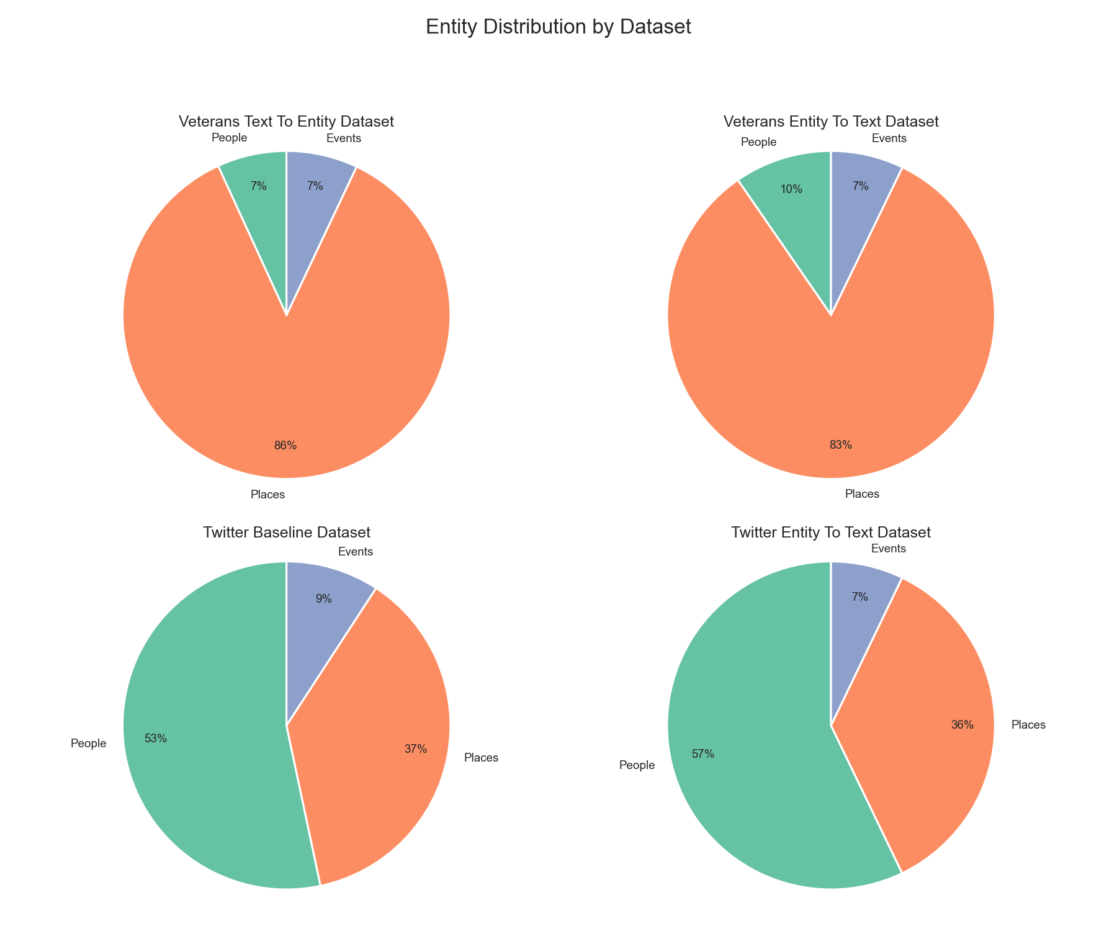

5.1.3 Illustrative Examples
Table 2 presents illustrative examples of implicit entity rewrites used in the dataset construction process. Each example displays the original text, the corresponding explicit entity and the rewritten implicit narrative. These examples demonstrate how the rewriting pipeline transforms explicit mentions into contextually grounded implicit expressions while maintaining the original narrative coherence and meaning.

Original text | Explicit entity | Entity Type | Implicitly rewritten narrative
I was just 15 years old, sitting in our apartment in Manhattan, listening to the radio | Manhattan | Places | I I was just 15 years old, sitting in our apartment in the heart of the bustling urban center, surrounded by towering skyscrapers and the vibrant energy of the city, listening to the radio was just 15 years old, sitting in our apartment in the heart of the bustling urban center, surrounded by towering skyscrapers and the vibrant energy of the city, listening to the radio
Ironically, just as he was about to be discharged in December '41, everything changed with the attack on Pearl Harbor | Pearl Harbor | Events | Ironically, just as he was about to be discharged in December '41, everything changed with the surprise military strike on the major U.S. naval base in the Pacific, where battleships lay anchored and aircraft were stationed

5.2 Implicit Entity Recognition Performance
Recognition performance was evaluated across 4 datasets (2 recollection-derived, 2 tweet-derived) using three recognition strategies: LLM-based, embedding-based, and hybrid RAG.
Table 3 reports results in terms of Hit@1, Hit@3, Hit@5, and global and filtered MRR.

Data | Implicit Recognition Method | hit@1 | hit@3 | hit@5 | global mrr | filtered mrr
twitter_entity_to_text | embedding based | 0.548 | 0.73 | 0.778 | 0.643 | 0.827
twitter_entity_to_text | hybrid rag | 0.849 | 0.889 | 0.889 | 0.868 | 0.976
twitter_entity_to_text | LLM based | 0.714 | 0.778 | 0.778 | 0.745 | 0.957
veterans_entity_to_text | embedding based | 0.103 | 0.16 | 0.181 | 0.133 | 0.735
veterans_entity_to_text | hybrid rag | 0.231 | 0.26 | 0.274 | 0.246 | 0.898
veterans_entity_to_text | LLM based | 0.215 | 0.288 | 0.288 | 0.248 | 0.861
veterans_text_to_entity | embedding based | 0.047 | 0.089 | 0.115 | 0.071 | 0.615
veterans_text_to_entity | hybrid rag | 0.23 | 0.276 | 0.287 | 0.253 | 0.879
veterans_text_to_entity | LLM based | 0.573 | 0.691 | 0.691 | 0.626 | 0.907
twitter_baseline | embedding based | 0.292 | 0.487 | 0.577 | 0.398 | 0.69
twitter_baseline | hybrid rag | 0.664 | 0.775 | 0.784 | 0.72 | 0.918
twitter_baseline | LLM based | 0.674 | 0.805 | 0.805 | 0.735 | 0.913

5.3 Implicit Entity Recognition Results
Figure 2: Global MRR comparison across datasets and methods
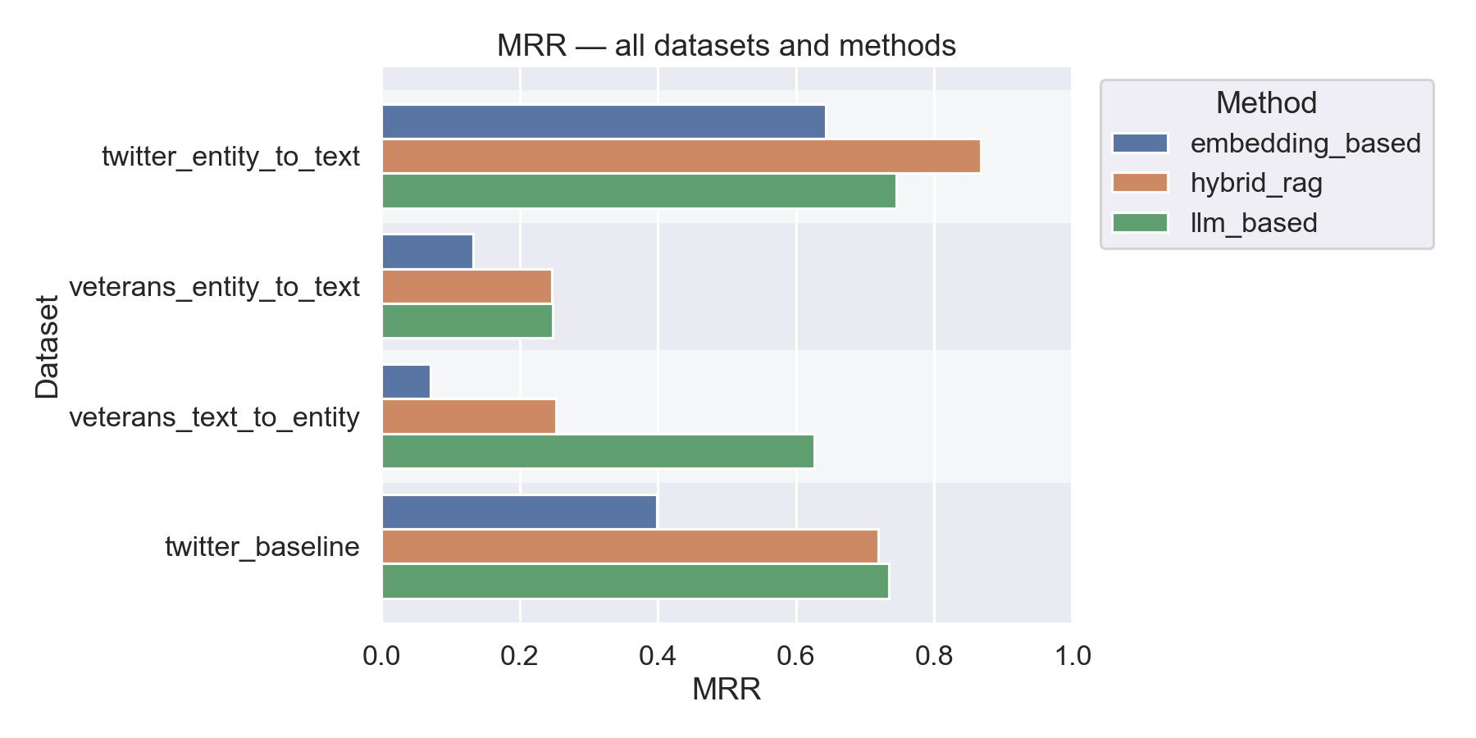
Figure 3: Bar plots of Hit@K for k = [1, 3, 5, 10] for each method per dataset.
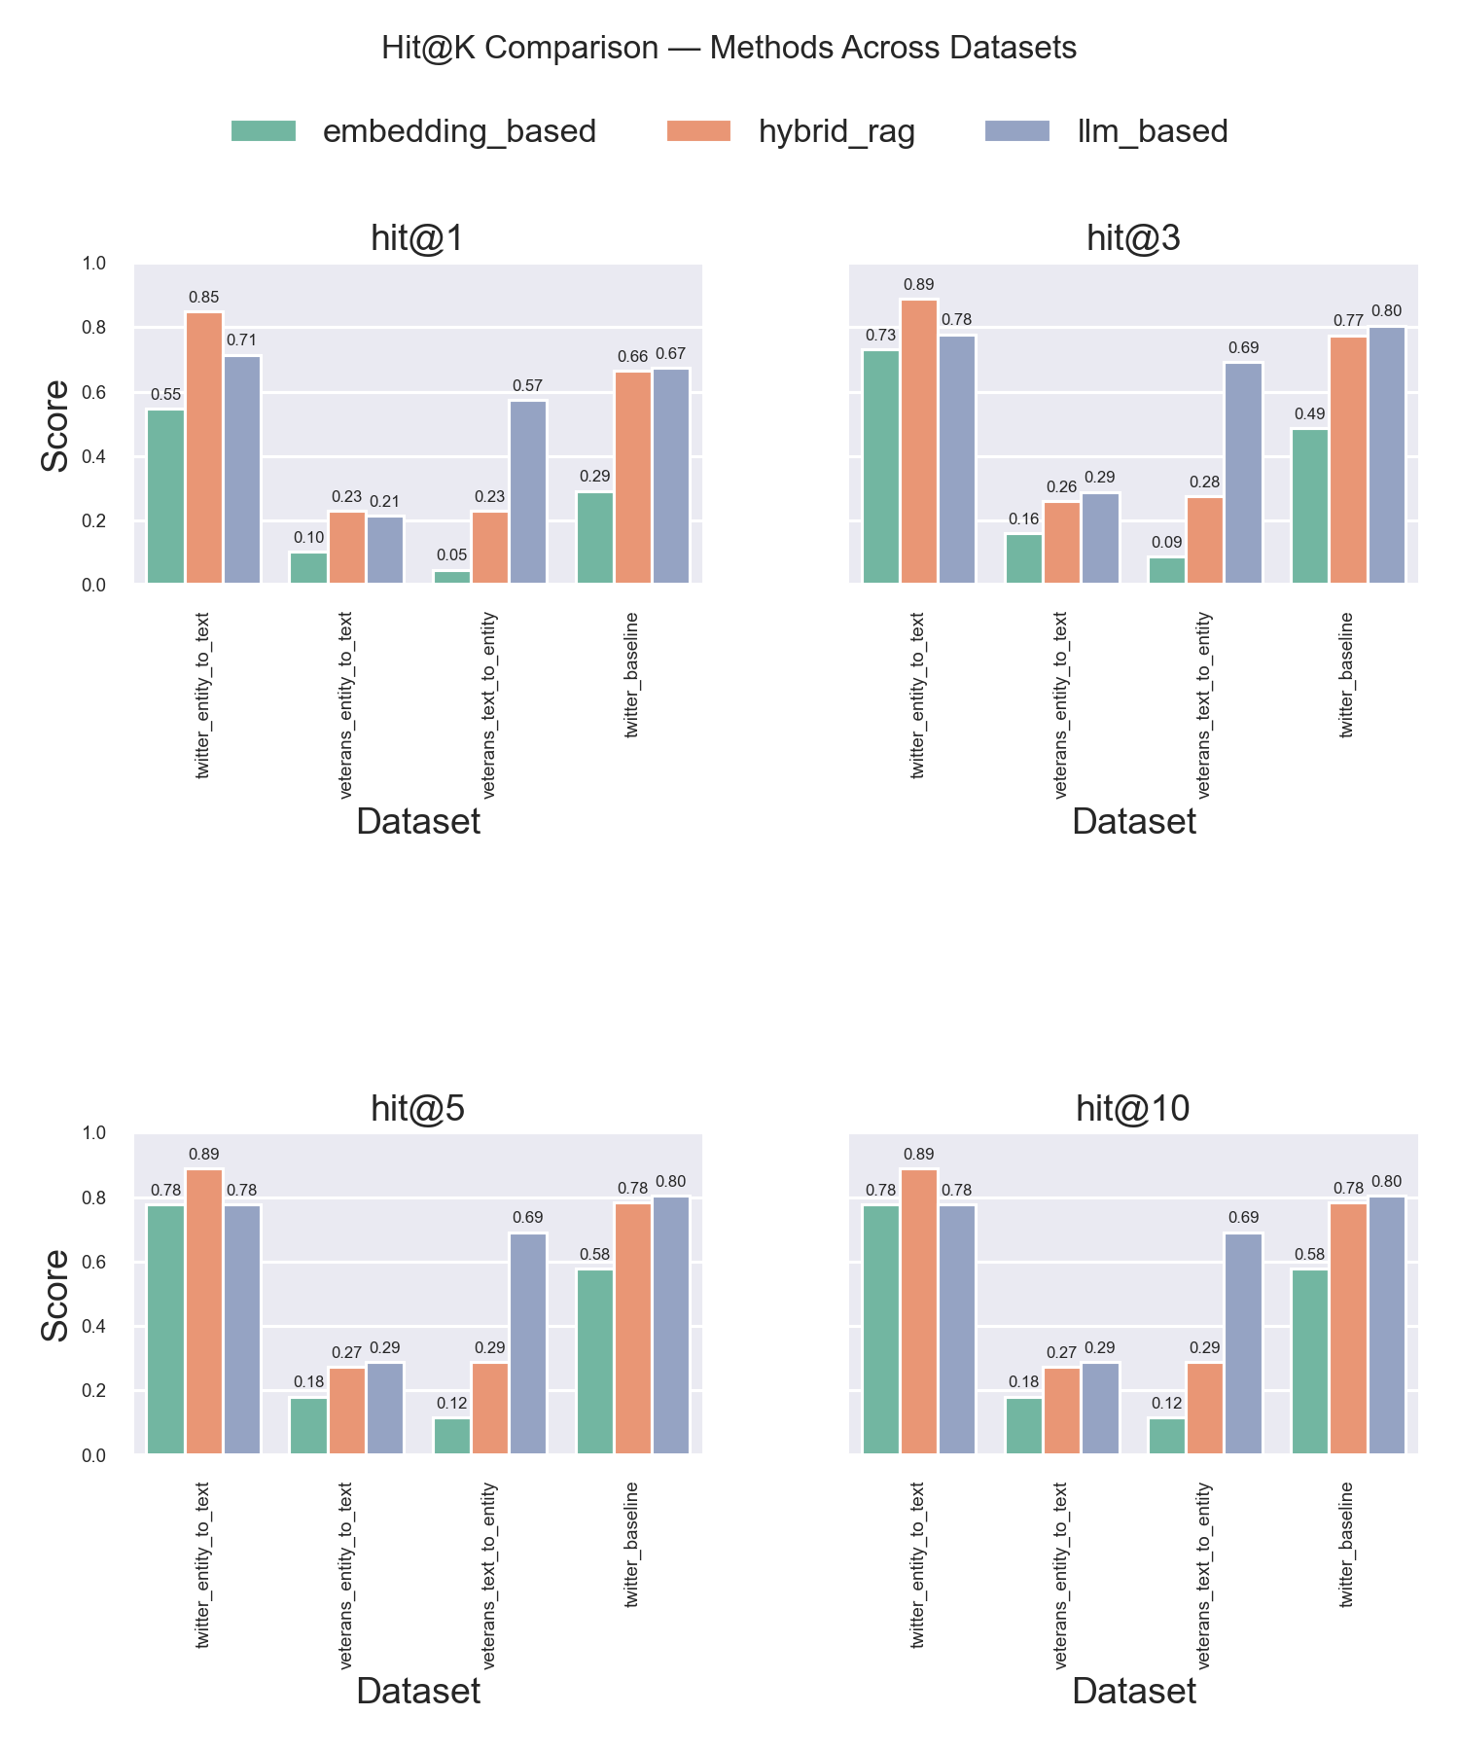

Figure 4: Global MRR comparison by entity type across datasets and methods
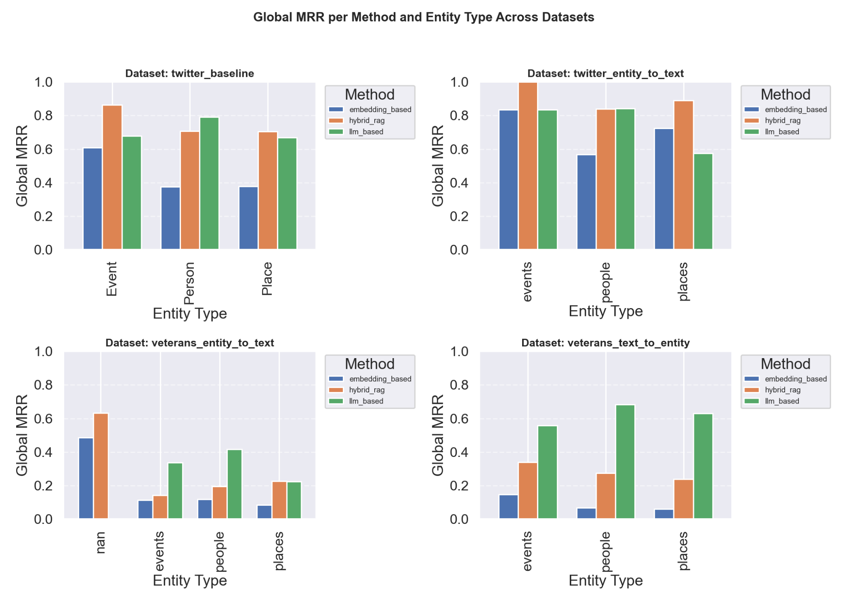

6. Discussion

7. References
Adnan, K., & Akbar, R. (2019). An analytical study of information extraction from unstructured and multidimensional big data. Journal of Big Data, 6(1), 1-38.
Peng, J., Zhao, M., Havrilla, J., Liu, C., Weng, C., Guthrie, W.,... & Zhou, Y. (2020). Natural language processing (NLP) tools in extracting biomedical concepts from research articles: a case study on autism spectrum disorder. BMC Medical Informatics and Decision Making, 20, 1–9.
Azcurra, D. J. L. (2012). A reminiscence program intervention to improve the quality of life of long-term care residents with Alzheimer’s disease. Geriatric Nursing, 33(2), 100–104.
Haslam, C., Haslam, S. A., Jetten, J., Bevins, A., Ravenscroft, S., & Tonks, J. (2010). The social treatment: The benefits of group interventions in residential care settings. Psychology and Aging, 25(1), 157–167.
Hosseini, H. (2022). Implicit Entity Recognition and Linking in Tweets (Doctoral Dissertation, Toronto Metropolitan University).
Hosseini, H., & Bagheri, E. (2021). Learning to rank implicit entities on Twitter. Information Processing & Management, 58(3), 102503.
Subramaniam, P., & Woods, B. (2012). The impact of individual reminiscence therapy for people with dementia: a systematic review. Expert Review of Neurotherapeutics, 12(5), 545–555.
Tadaka, E., & Kanagawa, K. (2007). Effects of the reminiscence group on elderly people with Alzheimer's disease and vascular dementia in a community setting. Geriatrics & Gerontology International, 7(2), 167–173.
Wang, J. J. (2007). Group reminiscence therapy for the cognitive and affective function of the demented elder
Benjamin, L. T. Jr., & Schwartz, B. L. (1998). Context and memory. In H. L. Roediger & S. M. McDermott (Eds.), Memory and Cognition (pp. 63–77),. Washington, DC: American Psychological Association.
Bluck, S., & Levine, L. J. (1998). Reminiscence as autobiographical memory: A catalyst for reminiscence theory development. Aging and Mental Health, 2(3), 188–199.
Holland, A. C., & Kensinger, E. A. (2010). Emotion and autobiographical memory. Emotion Review, 2(3), 232-253.
Schacter, D. L., & Addis, D. R. (2007). The cognitive neuroscience of constructive memory: remembering the past and imagining the future. Philosophical Transactions of the Royal Society B: Biological Sciences, 362 (1481), 773–786.
Subramanian, S., & Selinger, J. (2024). Promoting Personalized Reminiscence Among Cognitively Intact Adults Using Interactive Technologies. Journal of Medical Internet Research, 26(1), e49415.
ROEDIGER III, H. L., Bergman, E. T., & Meade, M. L. (2003). Repeated reproduction from memory. In Bartlett, Culture and cognition (pp. 135–154). Routledge.
Coleman, J. T. (2012). The reminiscence effect in autobiographical memory and tests of its prominent accounts.
Pillemer, D. B. (2023). Is it Time to Reminisce About the Future? Open Journal of Reminiscence and Life Review
Perera, S., Mendes, P., Sheth, A., Thirunarayan, K., Alex, A., Heid, C., & Mott, G. (2015, June). Implicit entity recognition in clinical documents. In Proceedings of the Fourth Joint Conference on Lexical and Computational Semantics (pp. 228–238).
Nash, R. A., Wheeler, R. L., & Hope, L. (2015). On the persuadability of memory: Is changing people's memories no more than changing their minds? British Journal of Psychology, 106(2), 308–326,.
Longo, J. E. (2018). Memory in Memoir & Biography: Science, Place, and Agency.
Schacter, D. L., Guerin, S. A., & Jacques, P. L. S. (2011). Memory distortion: an adaptive perspective. Trends in Cognitive Sciences, 15(10), 467–474.
Fontaine, W. (2014). Where memory fails, writing prevails: using the fallacies of memory to create an effective memoir. Assay: A Journal of Nonfiction Studies, 1(1).
Treder, M. S., Lee, S., & Tsvetanov, K. A. (2024). Introduction to Large Language Models (LLMs) for dementia care and research. Frontiers in Dementia, 3, 1385303.
Nisi, V., James, S., Bala, P., Del Bue, A., & Nunes, N. J. (2023). Inclusive Digital Storytelling: Artificial Intelligence and Augmented Reality to Re-Center Stories from the Margins. International Conference on Interactive Digital Storytelling (pp. 117–137).
Zhang, C., Chen, J., Li, J., Peng, Y., & Mao, Z. (2023). Large language models for human-robot interaction: A review. Biomimetic Intelligence and Robotics, 100131.
Milička, J., Marklová, A., VanSlambrouck, K., Pospíšilová, E., Šimsová, J., Harvan, S., & Drobil, O. (2024). Large language models are able to downplay their cognitive abilities to fit the persona they simulate. PloS one, 19(3).
Jung, D., Park, C., Eo, S., & Lim, H. (2023). Enhancing Machine Translation Quality Estimation via Fine-Grained Error Analysis and a Large Language Model. Mathematics, 11 (19), 4169.
Georgiou, A., Can, T., Katkov, M., & Tsodyks, M. (2023). Using large language models to study human memory for meaningful narratives. bioRxiv.
Marziali, R. A., Franceschetti, C., Dinculescu, A., Nistorescu, A., Kristály, D. M., Moșoi, A. A., Broekx, R., Marin, M., Vizitiu, C., Moraru, S. A., Rossi, L., & Di Rosa, M. (2024). Reducing Loneliness and Social Isolation of Older Adults Through Voice Assistants: Literature Review and Bibliometric Analysis. Journal of medical Internet research.
Tang, J. P. S., Liu, T., Lu, S., & et al. (2022). 'It was the deepest level of companionship’: Peer-to-peer experience of supporting community-dwelling older people with depression—a qualitative study. BMC Geriatrics, 22(1), 443.
Bozkurt, C., & Yıldırım, Y. (2022). A trip down memory lane: reminiscence therapy. J Educ Res Nurs, 19(3), 356-361.
Istvandity, L. (2017). Combining music and reminiscence therapy interventions for wellbeing in elderly populations: A systematic review. Complementary therapies in clinical practice, 28, 18–25.
Abdalrahim, A., Suliman, M., ALBashtawy, M., Alkhawaldeh, A., & Ta'an, W. A. (2023). Enhancing apathy treatment in Jordanian people living with dementia residing in care homes using virtual reality reminiscence therapy. Working with older people.
Hallford, D., Woolfit, M., Follett, A., Jones, E., Harrison, O., & Austin, D. (2024). Guided recall of positive autobiographical memories increases anticipated pleasure and psychological resources and reduces depressive symptoms: a replication and extension of a randomized controlled trial of brief positive cognitive-reminiscence therapy. Memory, 32(4), 465–475.
Iriss, (2011). Supporting Those with Dementia: Reminiscence Therapy and Life Story Work. Insights.
Woods, B., O'Philbin, L., Farrell, E. M., Spector, A. E., & Orrell, M. (2018). Reminiscence therapy is for dementia. The Cochrane database of systematic reviews.
Onnela, J. P., Waber, B. N., Pentland, A., Schnorf, S., & Lazer, D. (2014). Using sociometers to quantify social interaction patterns. Scientific reports, 4(1), 5604.
Kim, E. S., Cleary, S. J., Hopper, T., Bayles, K. A., Mahendra, N., Azuma, T., & Rackley, A. (2006). Evidence-based practice recommendations for working with individuals with dementia: group reminiscence therapy. Journal of Medical Speech-Language Pathology, 14(3), xxiii–xxiii.
Bluck, S., & Levine, L. J. (1998). Reminiscence as autobiographical memory: A catalyst for reminiscence theory development. Ageing & Society, 18(2), 185–208.
Cappeliez, P., Guindon, M., & Robitaille, A. (2008). Functions of reminiscence and emotional regulation among older adults. Journal of Aging Studies, 22(3), 266–272.
Bryant, F. B., Smart, C. M., & King, S. P. (2005). Using the past to enhance the present: Boosting happiness through positive reminiscence. Journal of Happiness Studies, 6, 227–260.
Butler, R. N. (1963). The life review: An interpretation of reminiscence in the aged. Psychiatry, 26(1), 65–76.
Hallford, D., & Mellor, D. (2013). Reminiscence-based therapies for depression: Should they be used only with older adults? Clinical Psychology: Science and Practice, 20(4), 452.
Hsieh, H. F., & Wang, J. J. (2003). Effect of reminiscence therapy on depression in older adults: A systematic review. International Journal of Nursing Studies, 40(4), 335–3 Science
Lewis, C. N. (1971). Reminiscing and self-concept in old age. Journal of Gerontology.
Wong, P. T. P. (2013). The processes of adaptive reminiscence. In The Art and Science of Reminiscing, Taylor & Francis, 23–35.
Bohlmeijer, E., Roemer, M., Cuijpers, P., & Smit, F. (2007). The effects of reminiscence on psychological well-being in older adults: A meta-analysis. Aging and Mental Health, 11(3), 291–300.
Ji, Z., Lu, Z., & Li, H. (2014). An information retrieval approach to short text conversations. arXiv preprint arXiv:1408.6988.
Serban, I. V., Sordoni, A., Bengio, Y., Courville, A., & Pineau, J. (2016). Building end-to-end dialogue systems using generative hierarchical neural network models. At the Thirtieth AAAI Conference on Artificial Intelligence,
Serban, I. V., Sordoni, A., Lowe, R., Charlin, L., Pineau, J., Courville, A., & Bengio, Y. (2017). A hierarchical latent variable encoder-decoder model for generating dialogues. At the Thirty-First AAAI Conference on Artificial Intelligence,
Weizenbaum, J., et al. (1966). ELIZA—a computer program for the study of natural language communication between man and machine. Communications of the ACM, 9(1), 36–45.
Wu, Y., Wu, W., Xing, C., Zhou, M., & Li, Z. (2016). Sequential matching network: A new architecture for multi-turn response selection in retrieval-based chatbots. arXiv preprint arXiv:1612.01627.
Chen, Y. W., Chen, Y., Peng, Y., & Leu, W. J. (2015). Reminiscence processes using mashups dedicated to the design of the lifelogging system. Advances in Research, 3(4), 382–390.
Tsao, Y. C., Shu, C. C., & Lan, T. S. (2019). Development of a reminiscence therapy system for the elderly using the integration of virtual reality and augmented reality. Sustainability, 11(17), 4792.
Schoneveld, J. (2020). Augmented reality photo album for people with dementia (Bachelor's thesis, University of Twente).
Imtiaz, D., Khan, A., & Seelye, A. (2018). A mobile multimedia reminiscence therapy application to reduce behavioral and psychological symptoms in persons with Alzheimer's. Journal of Healthcare Engineering, 2018, 1536316.
Hong, Z., Tchoua, R., Chard, K., & Foster, I. (2020). SciNER: extracting named entities from the scientific literature. In Computational Science-ICCS 2020: 20th International Conference, Amsterdam, The Netherlands, June 3–5, 2020, Proceedings, Part II 20 (pp. 308–321). Springer International Publishing.
Nadeau, D., & Sekine, S. (2007). A survey of named entity recognition and classification. Lingvisticae Investigationes, 30(1), 3-26.
Raza, S., Reji, D. J., Shajan, F., & Bashir, S. R. (2022). Large-scale application of named entity recognition to biomedicine and epidemiology. PLOS Digital Health, 1(12), e0000152.
Dai, Z., Luo, C., Li, Z., Tang, X., Lu, H., Goutam, R., & Zhang, H. (2024). RA-NER: retrieval-augmented NER for knowledge-intensive named entity recognition.
Ganea, O. E., & Hofmann, T. (2017). Deep joint entity disambiguation with local neural attention. arXiv preprint arXiv:1704.04920.
Kolitsas, N., Ganea, O.-E., & Hofmann, T. (2018). End-to-End Neural Entity Linking. Proceedings of the 22nd Conference on Computational Natural Language Learning, 519–529. doi:10.18653/v1/K18-1050. Retrieved from aclweb.org
Shen, W., Wang, J., & Han, J. (2014). Entity linking with a knowledge base: Issues, techniques, and solutions. IEEE Transactions on Knowledge and Data Engineering, 27(2), 443–460.
Sang, E. F., & De Meulder, F. (2003). Introduction to the CoNLL-2003 Shared Task: Language-Independent Named Entity Recognition. Proceedings of CoNLL-2003, 142-147. Retrieved from aclweb.org
Leaman, R., & Gonzalez, G. (2008). BANNER: an executable survey of advances in biomedical named entity recognition. In Biocomputing 2008 (pp. 652-663).
Hu, Y., Chen, Q., Du, J., Peng, X., Keloth, V. K., Zuo, X.,... & Xu, H. (2024). Improving large language models for clinical named entity recognition via prompt engineering. Journal of the American Medical Informatics Association, ocad259.
Naderi, N., Knafou, J., Copara, J., Ruch, P., & Teodoro, D. (2021). Ensemble of deep masked language models for effective named entity recognition in health and life science corpora. Frontiers in research metrics and analytics, 6, 689803.
Zhou, W., Zhang, S., Gu, Y., Chen, M., & Poon, H. (2023). Universalner: targeted distillation from large language models for open named entity recognition. arXiv preprint arXiv:2308.03279.
Majdik, Z. P., Graham, S. S., Shiva Edward, J. C., Rodriguez, S. N., Karnes, M. S., Jensen, J. T., ... & Rousseau, J. F. (2024). Sample Size Considerations for Fine-Tuning Large Language Models for Named Entity Recognition Tasks: A Methodological Study. JMIR AI, 3, e52095.
Dagdelen, J., Dunn, A., Lee, S., Walker, N., Rosen, A. S., Ceder, G.,... & Jain, A. (2024). Structured information extraction from scientific text with large language models. Nature Communications, 15(1), 1418.
Bhasuran, B., Murugesan, G., Abdulkadhar, S., & Natarajan, J. (2016). Stacked ensemble combined with fuzzy matching for biomedical named entity recognition of diseases. Journal of Biomedical Informatics, 64, 1–9.

